**BRAIN TUMOR CLASSIFICATION USING MACHINE LEARNING**

***Shruthi S, Nithya B, MD Nooruzzaman Khan***

*1 *Department of Electronics and Communication Engineering  
Meenakshi Sundararajan Engineering College, Anna University  
Chennai, India*

*2 *Department of Electronics and Communication Engineering  
Meenakshi Sundararajan Engineering College, Anna University  
Chennai, India*

*3 *Assistant Professor, Department of Electronics and Communication Engineering*  
*Faculty of Meenakshi Sundararajan Engineering College, Anna University*Chennai, India

**ABSTRACT**

Uncontrolled and rapid cell proliferation leads to the development of brain tumors. If it is not treated in the early stages, it could be fatal.. The imaging technology used to diagnose brain tumors is known as magnetic resonance imaging (or) MRI. In order to predict whether a brain tumor will develop into malignancy, early diagnosis of brain tumors is essential in medical practice. Deep learning is a practical and successful technique for picture classification. Many industries have used deep learning extensively, including medical imaging, because its application does not require the skills of a subject matter expert but requires a huge amount and a variety of data to produce appropriate classification results. The primary objective of a medical imaging project is to extract significant and accurate information from the image with the least errors possible. After the removal of these redundant artifacts, the images can be processed effectively. The first step of image processing includes processes such as conversion to gray-scale image, noise removal, and image reconstruction. In this research work, two different models are used to categorize brain tumors and their results were evaluated using performance metrics like accuracy and precision, which were impressive.

**Keywords:** Tumour, Performance, Classification, Accuracy, Data

1. **INTRODUCTION**

Brain tumors are the most common and fast-spreading disease, which leads to a very short life expectancy in its highest intensity. It happens due to the uncontrolled and rapid growth of cells. Before talking about brain tumors, one must understand what any tumor is. A tumor is a form of tissue that will grow out of control. It is nothing but extra cells growing in an uncontrolled manner. Brain tumor cells grow in a way that it eventually takes up all the nutrients meant for the healthy cells and tissues, which results in brain failure. At present, doctors discover the spot and the area of brain tumor by observing at the MR Images of the patient’s brain, which is definitely not the most efficient and time-saving way to go about it. This project uses a Deep Learning architecture CNN ( Convolution Neural Network ) to detect the brain tumors. The performance of the model will be to expect tumor is present or not in the image. Computer vision and AI has been a game changer in the world of cancer and cancer diagnosis because of the accurate diagnosis made by it as well as how little time it takes to make that very same diagnosis. In our project, it is found out what kind of tumor is present in the brain by observing the MRI Scanned Images of the brain. Generally, the primary objective of medical imaging project is to extract significant and accurate information from the images with the least errors possible. There are already many AI models which exist to detect cancer in the brain cells by looking at the MRI Images. MRI images are not 2-Dimensional in Nature, but are 3-Dimensional. This would mean that, the model ultimately has to detect grey areas in the brain by looking at the volume of the scanned image and not just the area. Our models perform their absolute best in this regard. Our model is a concatenation of two different models, VGG-16 and ResNet50. Computer scientists are focusing on precise diagnosis in less time because brain cancer is one of the deadly tumours and is capable of causing someone to lose their ability to live. because brain tumours can be identified early on, there are systems that facilitate their detection and classification. The most difficult clinical diagnosis task involves categorising brain tumours. The massive volume of data generated, however, makes it difficult to manually determine tumours over time. Convolutional neural network (CNN) technique is proposed in the present research for the detection of brain tumours.

Using methods for image processing, the model in the study detects the brain tumour. Four stages are involved in image processing procedures, and they are outlined below:

The initial stage in processing an image is segmenting it, after which its features are extracted using feature extraction, the image is then classified. From an inputted MRI Scanned image, it uses image processing techniques to enhance the performance of detection and classification of the brain tumour as glioma, pituitary, meningioma, or normal cells in the brain. As of the cancers themselves, there are mainly two kinds of tumours found in the medical literature, along with more than 150 additional kinds of tumours that have been identified. One is a primary brain tumour, which develops within the actual brain and is made up primarily of glial or non-glial cells that may be benign or malignant. Another is a metastatic tumour, which can develop anywhere in the body but frequently spreads to the brain via the circulation.

The World Health Organisation divides brain tumours into four groups: I, II, III, and IV. Grading systems I through II may be thought of as slow-developing, whereas grading systems III and IV are thought of as more aggressive and often have a worse prognosis. In this work, tumors as such as Glioma Tumour, Meningioma Tumour, Pituitary Tumour and normal cells are classified. If no tumour is present, no tumour. The anatomy or function of inner organs may be recorded and shown as pictures or films by certain medical image capturing tools such as X-ray, PET scans, MRI scans, CT scans, ultrasound scanners, and other similar devices. To effectively identify abnormalities or diagnose functional impairments, it is necessary to grasp the images and videos that are being used.

1. **METHODOLOGY**

The model is sent for training by incorporating Vgg-16 and resNet-50 architecture. The accuracy and precision of the trained model is observed and the predicted results are displayed on the screen

## Dataset Description

The MRI scan images of the brain present in our dataset and used in this project for brain tumour detection and classification, came from kaggle.com. The dataset consisted of greyscale MRI scans of the brain. The training dataset contains 3264 images, divided into four categories: 826 brain images with glioma tumours, 822 brain images with meningioma tumours, 827 brain images with pituitary tumours, and 395 brain images with no tumours.

## Deep learning models

In machine learning and deep learning, classification is a supervised learning method where the computer programs learn from data inputs provided to it and it will use this learning for classifying new observations. Binary classifications, such as determining if an individual is male or female, may be used, but the dataset can also include numerous classifications, such as determining whether a piece of mail has been spam or not. Document categorization, handwriting recognition, voice recognition, and biometric identification are a few examples of classification difficulties. Algorithms are taught via the use of labelled data in Supervised Learning. Algorithms use patterns and associations with previously unlabeled datasets to determine which label may be applied to new data.

## Convolution Neural Network

The potential of animals to perceive visuals is both interesting and basic. However, there are many hidden complexities during the process for a machine to analyse an image. What animals feel is the image being viewed by its eyes, which is then processed by the neurons and delivered to the brain for interpretation.

CNNs are normalized versions of multi layer perceptrons. Multi layer perceptrons usually means fully connected network, such that, each neuron in a layer is connected to all the neurons in its following layer. The full connectivity of these networks made these super vulnerable to over-fitting of info. Some of the ways to regulating and preventing of over fitting includes, penalizing parameters during training known as weight decay, or skipped connection, dropouts, etc.. CNNs featured a revolutionary regularisation technique that took use of the hierarchical pattern even in data and uses basic and naive patterns under their filters to synthesize points of increasing complexity. As a consequence, they are at the lowest end of the complexity and connectedness scale.

It represents a quantum leap in image comprehension, including image classification, segmentation, localization, detection, and so on. CNNs are built up of convolutional layers with weights and biases that could be learned, just like neurons, that also has the fundamental components like activation functions and various pooling layers, along with fully connected layers.

The first few layers might detect the obvious shape and big features and when it is about to proceed to the innermost layers or filters, they will be able to pick up very specific features like, eyes, ears, nose etc. CNN is what is used by major tech companies to detect faces, like apple uses this CNN which is a coupled with a ton of other layers to detect the face of an individual in face lock feature of theirs. Convolution layers are widely used since they are self-learning and are able to process huge amounts of data, as well as are excellent when it comes to detecting specific patters or features, which will indefinitely be very helpful in medical image processing to detect cancer.

## VGG-16

The Convolutional Neural Network (CNN) architecture known as VGG-16, or Visual Geometry Group, has many layers.. The softmax layer will be followed by 2 fully linked layers, each with 4096 nodes.An image of dimensionality is the model's input (224,224,3). With equal padding, the first two layers each contain 64 channels with a filter size of 3*3. After the strides (2, 2) max pooling layer, there are two layers with 3x3 convolutional filter layers. A max-pooling layer with strides (2,2) follows, which is identical to the layers that came before it. Filter sizes 3x3 are used in the next two convolution layers. 512 filters of 3x3 size with equal padding are distributed over two sets of three convolutional layers and a maximum pooling layer.

This image will then pass to the stack of two convolutional layers. For these convolution and max pooling layers, the filter used is of 3x3 instead of 11x11 as AlexNet and 7x7 as present in ZF Net. For some of these layers, they also use 1x1 pixels which is used to control the amount of input channels. Also, there will be a padding for one pixels after each convolutional layer to avoid the spatial features of the image.

Feature maps are formed once the convolutional and max pooling layers flatten it to create a shape feature vector (1,25088). Next, three fully connected layers are present, the first taking its inputs from the previous feature vectors and giving an output of a vector with shape (1, 4096), and the second layer also output a vector size of (1,4096), and the third layer outputs the required number of classes, and finally a soft-max layer is used to normalise the classification vectors after the output of the third fully connected layer.

## ResNet-50

Residuals can simply be seen as a subtraction of the features learned from an input of its layer. The model does this with many short-cut connections that directly connect the nth layer's input with other (n+i)th layer. From training these forms of networks is better than training deep convolution neural network and also the issue of reduced accuracy will be fixed. It has 152 layers and is 8 times deeper than VGG-19, although it has less computing complexity. Residual net ensembles had a lower error rate of 3.57 percent on the ImageNet test set than other models. The residual solves the challenge of training a truly deep architecture by incorporating identity skip connections, which allow the layers to duplicate their input to the next layer. It was a major innovation which had changed the training of deep convolution neural networks for tasks regarding image classification. While the initial Resnet had only 34 layers and had two layered blocks, other improved variants like the ResNet-50 made use of three layers blocks to have improved accuracy in less time required for training the model.

1. **MODELING AND ANALYSIS**

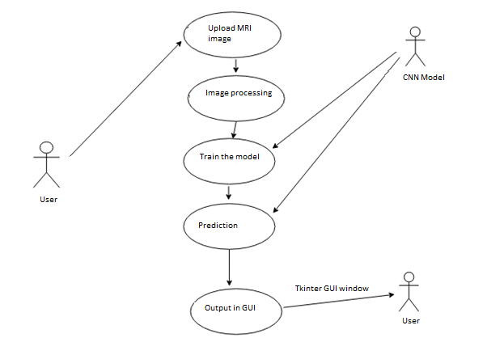

**Figure 1:** Use Case Diagram

1. **RESULTS AND DISCUSSION**

The model was trained on the dataset for a total of 9 epochs, and the history of last 4 epochs of training is shown in the above image. The model was saved and loaded again as the training time was extensive and could not be run at a single stretch. The model was fitted with the prepared training and validation datasets in a validation_split value of 0.1

Callbacks and checkpoints were used to retain the state and the learned weights of the model, which facilitates to resume training from where it was left. Callbacks can help us fix bugs more efficiently, and can help us to build a better model. They can help us to visualize how the model training is proceeding, and can also help prevent its over-fitting by applying early stopping or changing the learning rate of the model during each iterations. Using logs, the performance metrics of the model at each epoch was recorded and was later used to plot the results and observations.

Fig 3. Trainingand validation loss.

## Performance Metrics

With the help of performance measure it is found that accuracy is achieved about 94 %.

Fig 4. Performance metrics

Fig. 5 shows the performance metrics in which the precision, recall and f1_score is evaluated as 0.94.

## Confusion Matrix

A confusion matrix is a table that is used to define the performance of a classification algorithm. A confusion matrix visualizes and summarizes the performance of a classification algorithm.

From the confusion matrix, it is clear that almost all the classes have been predicted properly, with a few classes having some mis classified data points that are considered as false positives and false negatives. But when we looked at the performance metrics and the confusion matrix overall, it can be observed that the model is capable of predicting most of the classes properly, and can also perform well when new data is introduced to the model while prediction.

Fig 5: Confusion Matrix

D.Testing

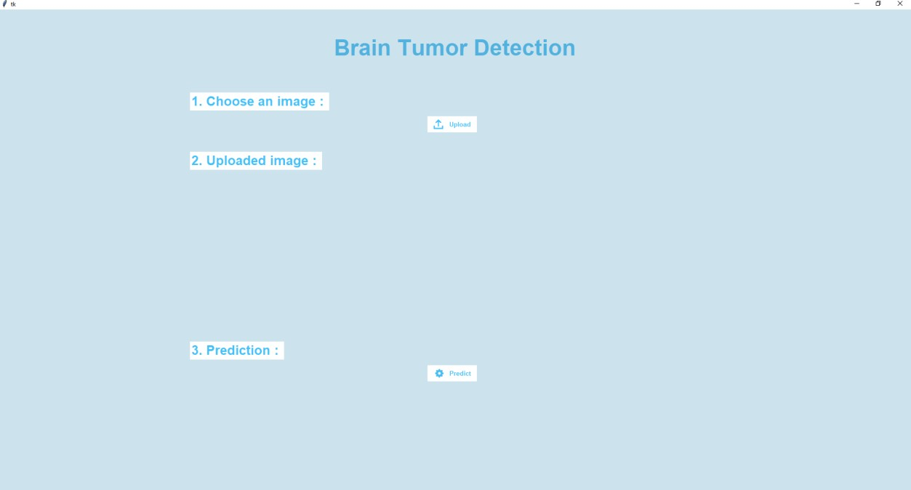

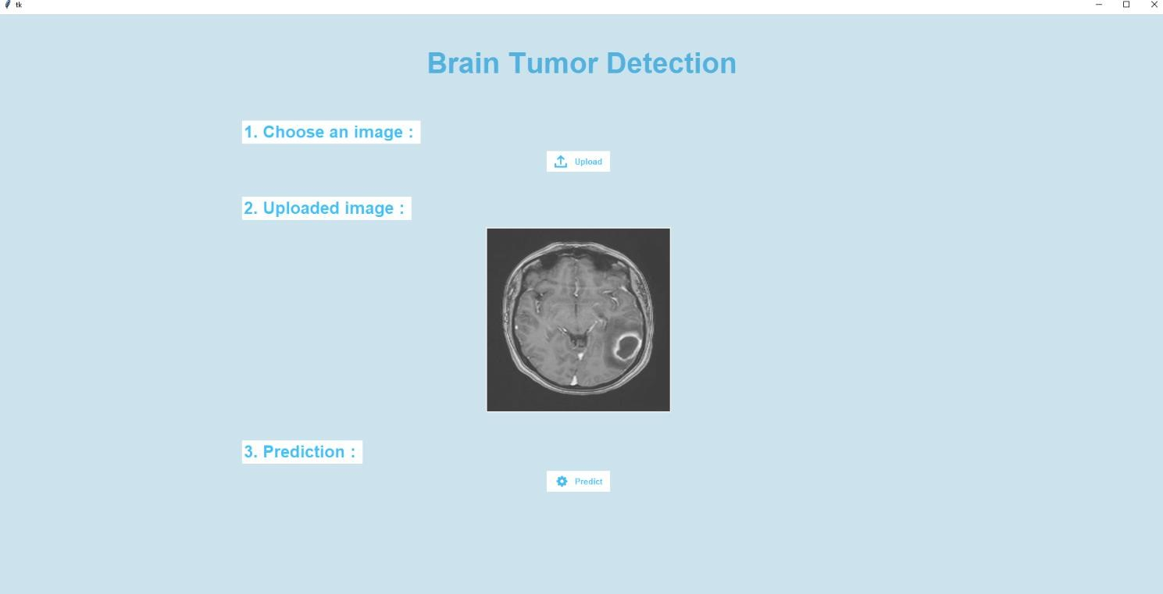

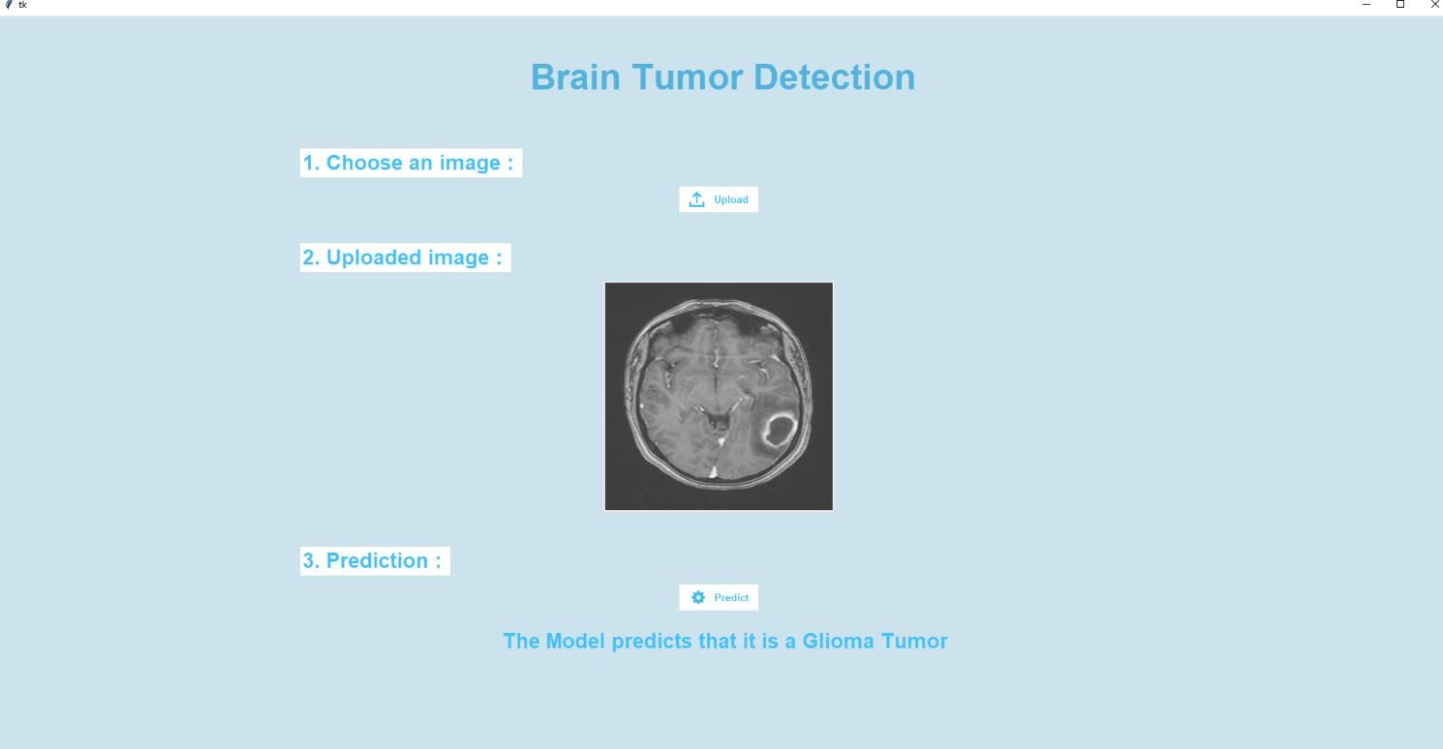

In this project, the output is visualized using GUI window with the help of libraries like Tkinter. It is a strong Python module that is frequently used to develop graphical user interface (GUI) applications. With Tkinter, GUI application development is incredibly simple and much quicker. The many widgets in this module can be utilised to create the GUI.. These include labels, checkboxes, buttons, frames, etc..

1. **CONCLUSION**

In this project, a new method is shown for automated classification of a brain tumour into 4 classes – glioma, meningioma, pituitary tumour and no tumour.The neural network model is a concatenation of two different models VGG-16 and ResNet50. VGG-16 is a Convolutional Neural Network (CNN) architecture with numerous layers introduced by Visual Geometry Group.And, ResNet50 has 152 layers and is 8 times deeper than VGG-19, although it has less computing complexity. Residual net ensembles had a lower error rate of 3.57 percent on the ImageNet test set than other models.This neural network model yielded a training accuracy of 97.8% and validation accuracy of 96.4%, which confirms that there was no over-fitting of the model during training.The model was successful in classifying the brain tumour classes with high performance in accuracy and precision. The efficiency of this model can be further improved by including more brain MRI scans with different weights and with various image augmentation techniques to increase the dataset size and to allow the model to perform as a more generalized and robust application for larger image databases.The aim is to build an automated system for improvement and classification of brain tumours.There are many medical imaging projects, and the major objective is to extract accurate and relevant information from these pictures with the least amount of mistake possible.The appropriate grouping and parameterization of the phases will enable the expansion of helper tools that would help for the initial diagnosis and the monitoring of the tumour identifications and locations. The key point of this strategy is to shape a robust CNN model that orders brain tumors using MRI scan images of the brain. A large number of training samples is applied to improve the performance of proposed method. This project will be using EDA on the exercise data and use several CNN models to examine them and obtain the optimal model. The proposed method is computationally effective and achieved more precise and reliable results which are better than current methods for classification of brain tumor.

1. **REFERENCES**
2. Amin, J., Sharif, M., Haldorai, A.,2021, Brain tumor detection and classification using machine learning: a comprehensive survey. Complex Intelligent Systems
3. Emrah Irmak, , 10 April 2021, Multi-Classification of Brain Tumor MRI Images Using Deep Convolutional Neural Network with Fully Optimized Framework, Iranian Journal of Science and Technology, Transactions of Electrical Engineering.
4. G. Hemanth, M. Janardhan and L. Sujihelen, 2019, Design and Implementing Brain Tumor Detection Using Machine Learning Approach," 2019 3rd International Conference on Trends in Electronics and Informatics (ICOEI)
5. R. D. Shirwaikar, K. Ramesh and A. Hiremath, 2021 A survey on Brain Tumor Detection using Machine Learning, 2021 International Conference on Forensics, Analytics, Big Data, Security (FABS)
6. Miglani, H. Madan, S. Kumar and S. Kumar, 2021, "A Literature Review on Brain Tumor Detection and Segmentation," 2021 5th International Conference on Intelligent Computing and Control Systems (ICICCS)
7. Sinha, A. R P, M. Suresh, N. Mohan R, A. D and A. G. Singerji, 2021, Brain Tumour Detection Using Deep Learning, 2021 Seventh International conference on Bio Signals, Images, and Instrumentation (ICBSII).
8. S. Rajkumar, K. Karthick, N. Selvanathan, U. K. B. Saravanan, M. Murali and B. Dhiyanesh, 2021, Brain Tumor Detection Using Deep Learning Neural Network for Medical Internet of Things Applications, 2021 6th International Conference on Communication and Electronics Systems (ICCES).
9. Sivaramakrishnan, A., & Karnan M., 2013, A Novel Based Approach for Extraction of Brain Tumor in MRI Images Using Soft Computing Techniques.
10. Li S, Kwok JT, Tsang IW, Wang Y. 2004, Fusing images with different focuses using support vector machines.” IEEE Trans Neural Netw.
11. Shubhangi, D. 2017, Brain Tumor Segmentation: The Survey on Brain Tumor Segmentation Techniques. International Journal for Research in Applied Science and Engineering Technology.
12. Yamashita, R., Nishio, M., Do, R.K.G. et al. Convolutional neural networks: an overview and application in radiology.
13. Müller, D., Kramer, F. MIScnn, 2021, A framework for medical image segmentation with convolutional neural networks and deep learning, BMC Med Imaging.